|  |  |  |  |
| --- | --- | --- | --- |
| Technical White Paper |  |  |  |

# Title

Oracle ACMP (Application Change Management Pack) as Configuration, Set Up and Deployment Tool

# Product(s)

Oracle ACMP, Oracle E-Business Suite, Oracle Enterprise Manager Cloud Control

# Introduction

Oracle E-Business Suite is a widely accepted and used Enterprise Resource Planning (ERP) software product. Lot of organizations have implemented Oracle E-Business Suite product to run their various business functions such as Finance, Manufacturing, Human Resources, Purchasing, Payroll etc. Due to complexity in its architecture, duration of implementation, maintenance costs as well making them align with the Oracle Support categories it becomes very important to have a proper deployment strategy, analysis of current patch levels for each modules within Oracle E-Business Suite, security or critical patch analysis, upgrade path, customizations planning and implementation. It requires a lot of effort and planning to perform the activities in the day to day basis or by month or by quarter along with less disruption of downtime on Oracle E-Business Suite systems and hence it is important we automate many of these tasks to have a smooth and error free deployments, fixes, upgrades or setup/configuration movements within less duration of time with no issues.

Oracle came up with Application Change Management Pack (ACMP) which is an extension of the Oracle Application Management Pack (AMP) and installed within the Oracle Enterprise Grid/Cloud Control to centrally manage and perform the functions such as deployments, analyzing and applying standard Oracle database and application patches, package the customizations code, deploy customizations, define setups for configurations and implementing it as well. Oracle ACMP can be used with Oracle E-Business Suite as well as for any customized applications that are built in JAVA or applications that are deployed under Oracle SOA Suite or Oracle Fusion Middleware.

Oracle ACMP is implemented in large scale projects where we have multiple Oracle E-Business Suite instances to manage or wherever there is a project implementation for an organization across the globe to cater to the needs.

# ACMP Components

Oracle ACMP has three main components and they are briefly discussed as below:

**Patch Manager**

Patch Manager provides a front end interface to deploy patches across multiple Oracle E-Business Suite Instances. Patch Manager integrates with My Oracle Support and downloads patches, can analyze patches, and deploy the one or more (merged) patches in single node as well as multiple node Oracle E-Business Suite instances. It also deploys custom packages/patches build using Customization Manager. Patch Manager also allows scheduling of patches at times to be applied at various instances, such flexibility reduces the presence of the DBA overnight as well his effort to apply the patches.

**Customization Manager**

Customization Manager allows to package the Oracle E-Business Suite customizations as a custom patch which is then migrated and deployed using Patch Manager in one or many instances. Customization Manager integrates successfully with third party source code configuration tools such as Subversion and GIT to extract the files and package them accordingly. Customization Manager is compatible with almost all types of files formats and extensions that are allowed in Oracle E-Business Suite. It also validates all these files to check if it conforms to the coding and development standards set in Oracle E-Business Suite. It is a great tool to handle customizations in Oracle E-Business Suite and one of its kind for automating the packaging and deployments of Customization in Oracle E-Business Suite.

**Setup Manager**

Setup Manager allows defining implementation projects with the help of which we can migrate several Oracle E-Business Suite configuration and setups such as responsibility, roles, flex fields, security rules, users etc. from one instance to another instance thus saving time and effort in re-entering the configurations in another instance. Setup Manager is actually an extension of Oracle iSetup module provided in Oracle E-Business Suite but centrally managed and available with ACMP.

All these three components are accessible and can be seen and accessed from the Oracle ACMP Change Management Dashboard. Automation of packaging the custom code, applying standard as well and custom patches and moving configuration and setups from one instance to another are the main features of ACMP which makes it a favorite for large scale Oracle E-Business Suite implementations.

# Purpose of the white paper

The white paper is intended for audiences who have working in Oracle E-Business Suite projects in roles such as Oracle E-Business Suite DBAs, Enterprise Architects, Oracle Application Developers, JAVA developers and Configuration Managers.

# Architectural Diagram of Oracle ACMP

Figure 1.1 shows a logical view of Oracle ACMP architecture and its integration with various Oracle Products and configuration management tools:

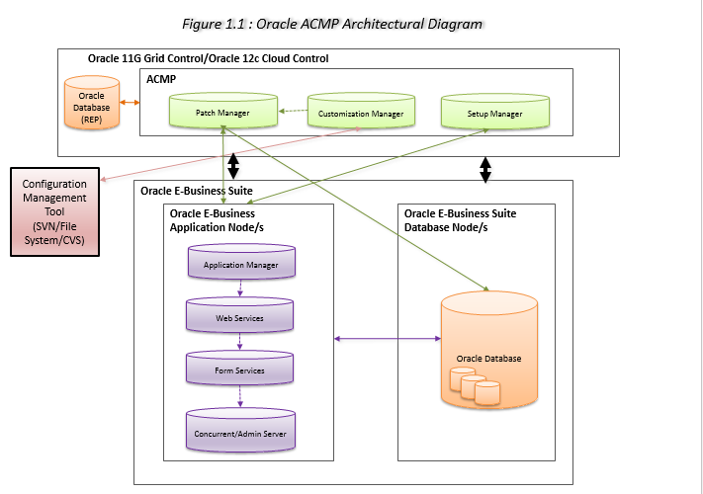

**Oracle 12c Cloud Control / Oracle 13c Cloud Control**

Oracle Grid or Cloud Control infrastructure installation is required to install Oracle Application Management Pack (AMP) which is used mainly as a framework for Oracle ACMP and other database and application plugins such as Oracle E-Business Suite, Oracle WebLogic, SQL server, MySQL etc. For Oracle ACMP we would need the following installation to perform on top of Oracle AMP.

* Grid/Cloud Control Plugin for Oracle E-Business suite.
* Management Agent Plugin to be installed in Oracle E-Business Suite targets.

**Oracle E-Business Suite**

Oracle E-Business Suite installations can be single and multi-node installations. In brief the architecture of Oracle E-Business Suite consists of following components:

* Oracle Application Manager is tool for managing and monitoring Oracle E-Business Suite. It also provides a framework for interacting with various services running as part of Oracle E-Business Suite Application server/node.
* Web Services is a component of the Oracle Application Server/Node which is used to receive client requests basically HTTP requests from intranet/internet network and serve those requests. The sub-components of the Web Services are Oracle HTTP Server, Java Servlet Engine (OC4J) and Oracle Process Manager (OPMN). From Oracle E-Business Suite 12.2 onwards Oracle WebLogic replaces OC4J component.
* Form Services is a component of the Oracle Application Server/Node which create forms runtime processes for each client connections to facilitate and show Oracle Forms to the client requests from their desktop. The HTTP requests from Webservices are received by Forms Listener Servlet which in turn manages the forms runtime processes for each of the client requests.
* Concurrent Manager server is a component to schedule and run batch jobs, reports, interface programs and other business programs. It reads the scheduling information from the database table and processes the programs till its completion as well as has manages them.

Admin Server is a component which runs admin services by which Oracle E-Business Suite DBA performs administration activities such as start, stop the services, run AD utilities such as adpatch/adop, adsplice, adadmin, adctrl, admrgpch etc.

**Configuration Management Tool**

Configuration Management plays an important role in Oracle ACMP such as it stores the source code, validates the structure and files as per the deployment process and project guidelines. It also helps in version control of the code files, creating baselines or tags for deployment, track and maintain change control as well as auditing the changes done to files. There are lot of Configuration Management tools available such as Subversion, CVS (Concurrent Versions Systems), SourceForge, Revision Control Systems (RCS), GIT etc. Oracle ACMP integrates with Subversion, RCS and CVS to fetch the source code for packaging using Customization Manager.

# Technical Design and implementation

The exhaustive technical design and implementation is available in KMS. The name of the document is **Installation, Configuration and Using ACMP for Customizations-V1.0.doc**

# Summary

In this white paper we have covered the basic introduction to Oracle ACMP, how it is useful to implement Oracle ACMP as a deployment tool in large scale Oracle E-Business Suite projects and also custom JAVA projects where Oracle E-Business Suite is also used. The basic components of Oracle ACMP and it purpose and use in brief. We went through the Architectural Design of Oracle ACMP and well summarized each one of those products in brief.

It is expected from the reader to take additional effort to go through the products defined in the architecture design if they aren’t aware in detail some of these components. Also, refer to the technical design documentation available in KMS.

**Index**

A

ACMP Change Management Dashboard 3

ACMP Components 2

Admin Server 5

Application Change Management Pack 1

Architectural Diagram of Oracle ACMP 3

C

Cloud Control 1, 4

complexity 1

Concurrent Manager 5

configuration 1, 2, 3

Configuration Management 5, 6

configurations 1, 3

Customization Manager 2, 6

customizations 1, 2

D

DBA 2, 5

deployment 1, 5, 6

E

Enterprise Resource Planning 1

extension 1, 3

extensions 2

F

files formats 2

fixes 1

Form Services 5

H

HTTP requests 5

I

implementation 1, 2

interface 2, 5

Introduction 1

J

JAVA 1, 3

O

Oracle ACMP 1, 2, 3, 4, 5, 6

Oracle Application Manager 5

Oracle Fusion Middleware 1

Oracle Grid 4

Oracle Process Manager 5

Oracle SOA Suite 1

Oracle Support 1, 2

organizations 1

P

**Patch Manager** 2

programs 5

Purpose of the book 3

R

reports 5

S

Setup Manager 2

Subversion 2, 6

Summary 6

systems 1

W

Web Services 5